Maxime Junca-Quintero
📧 maximequintero@gmail.com | 📍 Toulouse, France | 📞 +33769099145 | LinkedIn

Professional Summary
Project & Operations Manager with expertise in data analytics, strategic leadership, and cross-functional team coordination. Experienced in Business Intelligence with a growing focus on consulting. Enjoys optimizing and managing technical projects.
Professional Experience
- Operations Manager | Amazon Hub | Paris, France | June – Oct 2024
Oversaw Lockers fleet maintenance; optimized supplier coordination; gained in-depth operational knowledge.
- Project Manager - Intern | Amazon Transportation Services (ATS) | London, UK | Jan – Jun 2023
Enhanced metric visibility with a consolidated reporting solution; in charge of change management regarding our internal reporting tool; developed SQL skills through “Data at Amazon” training.
- Founder | Tenoris Analytics | Toulouse, France | Nov 2021 – Present
Founded Tenoris Analytics, leading digital project development and technical team management for innovative SaaS solutions.

Education
- NEOMA Business School | Reims, France & Dublin City University | Dublin, Ireland
BBA - CESEM – Global Business, Specialization in Business Analytics | Sep 2019 – May 2024
Double degree. Core business training in France, followed by data-focused specialization in Ireland (Python, SQL). Thesis on patent value contribution using regression models.
- ESCP Business School | Paris, France | MSc in Strategy and Organisation Consulting | Sep 2025 – Dec 2026
MSc focused on designing and leading structured business initiatives.
Skills
- Project Management & Leadership
- Data Analysis & Business Intelligence (SQL, Python, Excel/CSV modeling, Google Analytics 4, Google Tag Manager)
- Strategic Thinking & Business Acumen
- Technical Development (Git, Web apps, Database tools)
- Communication & Multilingualism
- Adaptability & Change Management

Publications


- NXU Think Tank – Participation in discussions on the practical use of AI and its societal and economic impact.
E-Portfolio Link
About me – Experiences – Projects – Certifications – References – Publications
Letter of Reference Amazon

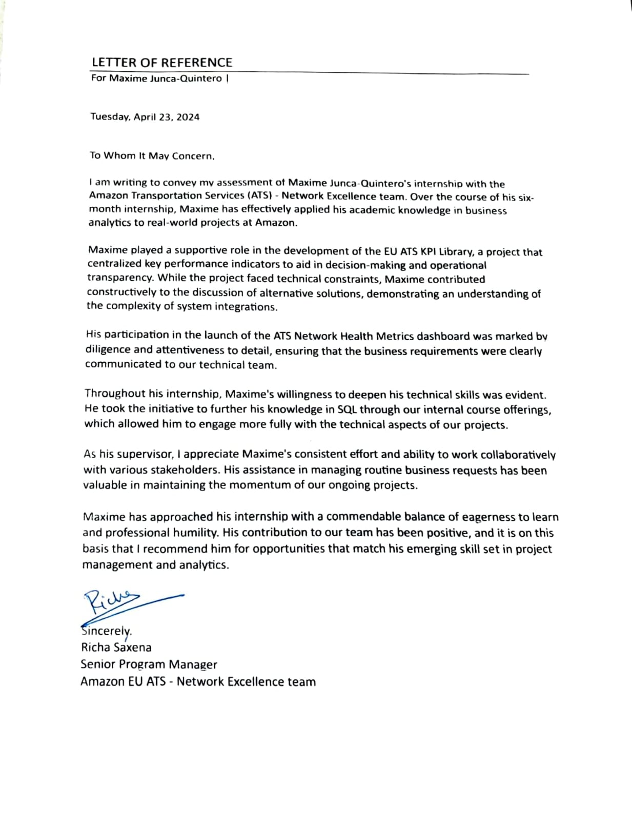

Letter of Reference Dublin City University

